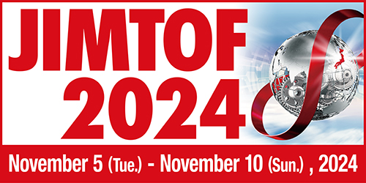

INVITATION FOR JAPAN PRESS CONFERENCE
AT SIMTOS 2024

Japan Machine Tool Builders’ Association
Tokyo Big Sight Inc.

Cordially invite you to press conference at SIMTOS 2024.

Date: Wednesday, April 3, 2024
Time: 11:00 ～12:00
Place: Room “207A” at KINTEX1
Content: Current Situation of Japanese Machine Tool Industry
General Information of JIMTOF2024

Yes, I will attend □

No, I will not attend □

Name | Title | Company
Please send reply to Ms. Keiko Honda (honda@jmtba.or.jp). Thank you.

