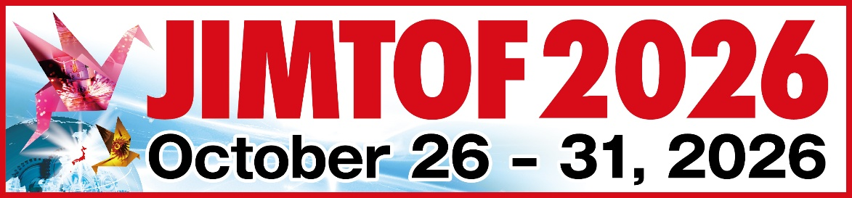

JIMTOF 2026 Press conference for Overseas Media

Japan Machine Tool Builders’ Association
Tokyo Big Sight Inc.

Cordially invite you to press conference on JIMTOF 2026.

Date: Wednesday, October 28, 2026
Time: 14:00 ～15:00
Place: Room 609, Conference Tower of Tokyo Big Sight
Content: Current Japanese Machine Tool Industry
Highlight of JIMTOF 2026

Yes, I will attend □

No, I will not attend □

Name | Title | Company

Please send reply to Ms. Keiko Honda (honda@jmtba.or.jp). Thank you.

