

INVITATION FOR
JAPAN DAY (JIMTOF 2026 NETWORKING)
at SIMTOS 2026

Cordially invite you to Japan DAY (JIMTOF 2026 NETWORKING)
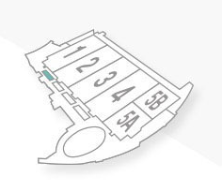
at SIMTOS 2026.

Date: Tuesday, April 14, 2026
Time: 14:00 ～15:00
Place: Room 302, KINTEX 1（3F）

Content
This is a new style of event where you can casually exchange information
about JIMTOF 2026 and Japan's machine tool industry while enjoying
afternoon tea and snacks. Please join us!

Yes, I will attend ☐

No, I will not attend ☐

Name | Title | Company | e-mail
Please send reply to Ms. Keiko Honda (honda@jmtba.or.jp). Thank you.

Japan Machine Tool Builders’ Association


Tokyo Big Sight Inc.



